Camp Quest NorthWest Meeting Minutes

Teleconference Meeting – https://us02web.zoom.us/j/4522050347
Wednesday, August 31, 2022, 6:30pm (social), 7pm (official start)

Board Members in attendance:
President – Michael Warbington
Treasurer – Meg Vimes
Secretary – Jami Gramore
Members at Large – Loki Lyrix-Astyriel, Ben Frey, Andrea Kunkle, Meg Jackson, Cece Crosby

Others in Attendance: Sharon Zolnowsky, Terry, Moss, Vianne, Liam, Sparrow, Carol K, Bruce, Ellowyn, Sam, Becky

- The attendees shared stories about getting their wisdom teeth removed.

Meeting Minutes:

Start time: 7:08 pm

Approving 7/27/2022 meeting minutes:
- The board approved the minutes from the previous meeting.

Camp Kirby Debrief:
- Camp was awesome! Campers, staff, and senior staff had a great time.
- COVID checks went smoothly. Tested every staff and camper. Needed a little more communication during the registration about the order of operations.
- What made this session so successful?
  - Really committed group of LTs, and more than usual.
  - Lots of returning staff and new campers-turned-staff who were committed and knew what to do.
  - Rearranged the afternoon schedule so staff could get enough breaks, and campers could have more afternoon choice activities.
- What would help make it better? Giving cabin counselors more specific information about the campers, like dietary habits, family relationships.

Outreach Committee:
- Volunteers have been talking in Discord about restarting this committee. Several folks are interested and contacted Phil.
- Need to start recruiting staff in particular.
- Suggestion to make all the Board members be a part of Outreach. Still need a committee chair.
- Need to create new materials like flyers, brochures, and business cards.
- Have a CQNW table at events such as:
  - Emerald City Comic-con
  - Norwescon
  - ECCC
  - GSA & Pride meetings
  - PaxWEST
  - Geekgirl
  - College career fairs
- Bring back community radio ads. Use as an opportunity to record ads to play in other areas as well. Relevant podcasts?
- We could start our own podcast. Talk to Sam.
- Sam: What does the organization want to do? In the position to help. Radio show content programming, like a podcast.
- Sam wants folks to come down and record PSAs about their experience at camp.
  - Signal Becky for PSA scheduling.
- Ben: Camper-driven podcast. News related, rights related, whatever.

Treasurer’s Report:
- Meg V emailed the Budget and Balance Sheets to the Board.
- Nonprofit report has been filed. Mike’s address is being used.
- Meg V is still figuring out the budget. Pretty much breaking even this year, which is good.
- Discussed camperships in regard to the budget.

Grants Committee:
- Ben: Wants to change the name to the Campership Committee, because that’s mostly what the committee handles. Also handles travel for the Summit.
- Used up most of the budget. Ben and Andrea discussed the exact amount.

Registration and Staffing Committee:
- Andrea submitted the post-camp session report for August.
- Andrea: CQ’s IT system changing from Active to Ultracamp.
- Andrea does not want to be registrar anymore and is looking for her replacement. Need to onboard the new person as well.
- Cece would like to help more with Staffing Committee.
- Andrea will ask about recording the Ultracamp onboarding training and invite those who are interested. Several board members would like to learn how to use it.

Policy Committee:
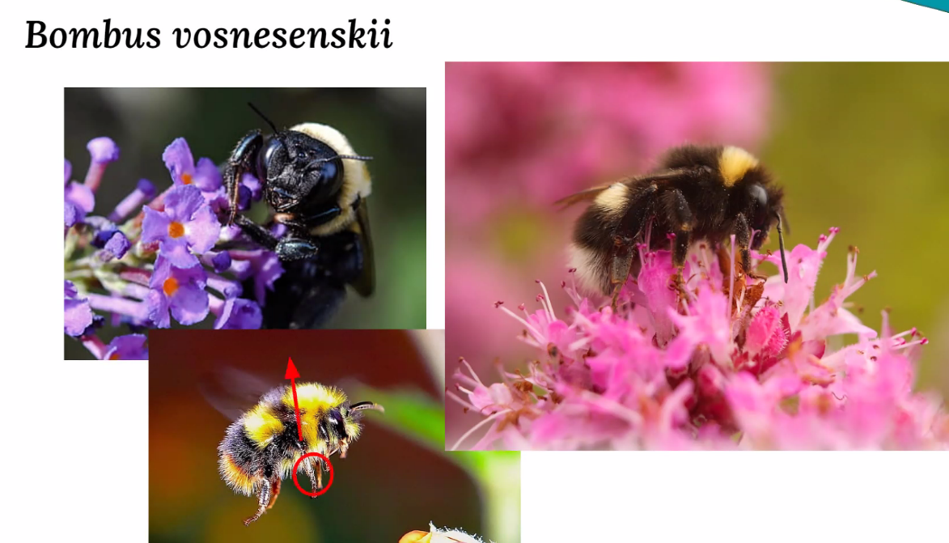

- ACA Process
  - Site visits: July 2023 (Wasko), Aug 2023 (Kirby)
  - Policy completion estimate: TBD
  - What does CQNW need to do?
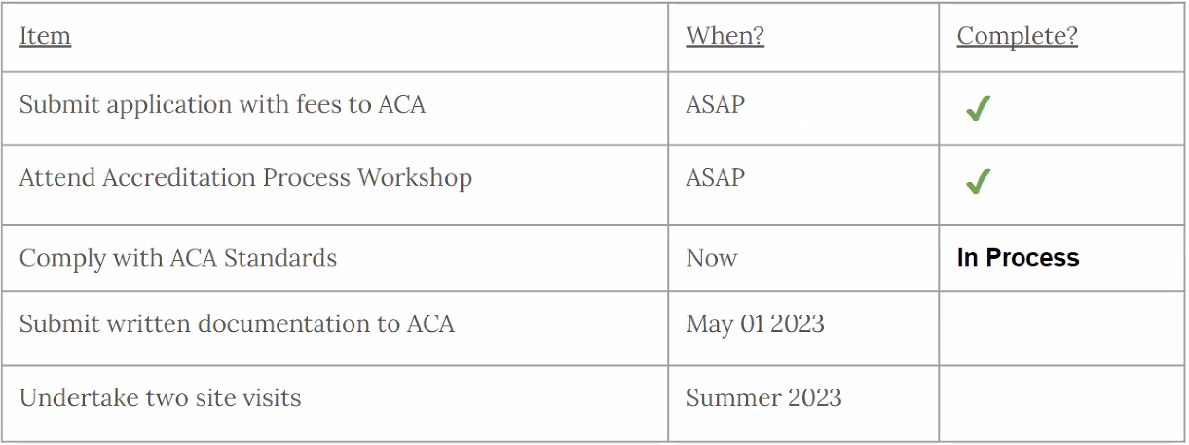
  - Core: 4/5 complete
  - Administrative: 18/25 complete
  - Facilities: 20/20 complete
  - Healthcare: 11/16 complete
  - Staff: 20/30 complete
  - Programming: 20/25 complete
- Next meeting: poll expected next week.
- Sparrow will continue to chair the Policy Committee. Likely cannot attend the site visits.
- Committee is precisely on budget.
- The Board gave a big 🌟Thank You🌟 to Sparrow for working so hard on our policies. 💕

CQNW Board Elections:
- Board elections will be held at the next board meeting.
- The following 4 positions are up for re-election:
  - Treasurer: Meg Vimes
  - Secretary: Jami Gramore
  - 2 Members-at-Large: Ben Frey, Andrea Kunkle
- Candidates need to be nominated at least two weeks prior to the meeting.
- Treasurer: Meg V will keep serving in this role, but would prefer to hand it to someone who really wants the job.

- Phil wants to be camp director of July Session 2023.
- Vote:
  - Meg Vimes made a motion, seconded by Mike Warbington, to approve Phil Cole as camp director for the 2023 July Camp Session. The motion passed unanimously.

Important Upcoming Dates:
- Tentative 2023 Waskowitz dates: 7/1/23 – 7/8/23
- CQ Summit: 11/4/22 – 11/6/22

Next Board Meeting:
September 21, 2022 at 6:30pm (for socializing), 7pm (official start time)
Location: https://us02web.zoom.us/j/4522050347

End time: 9:12 pm

